HTML and JavaScript on IP tracking. I used freeip.net API in the coding

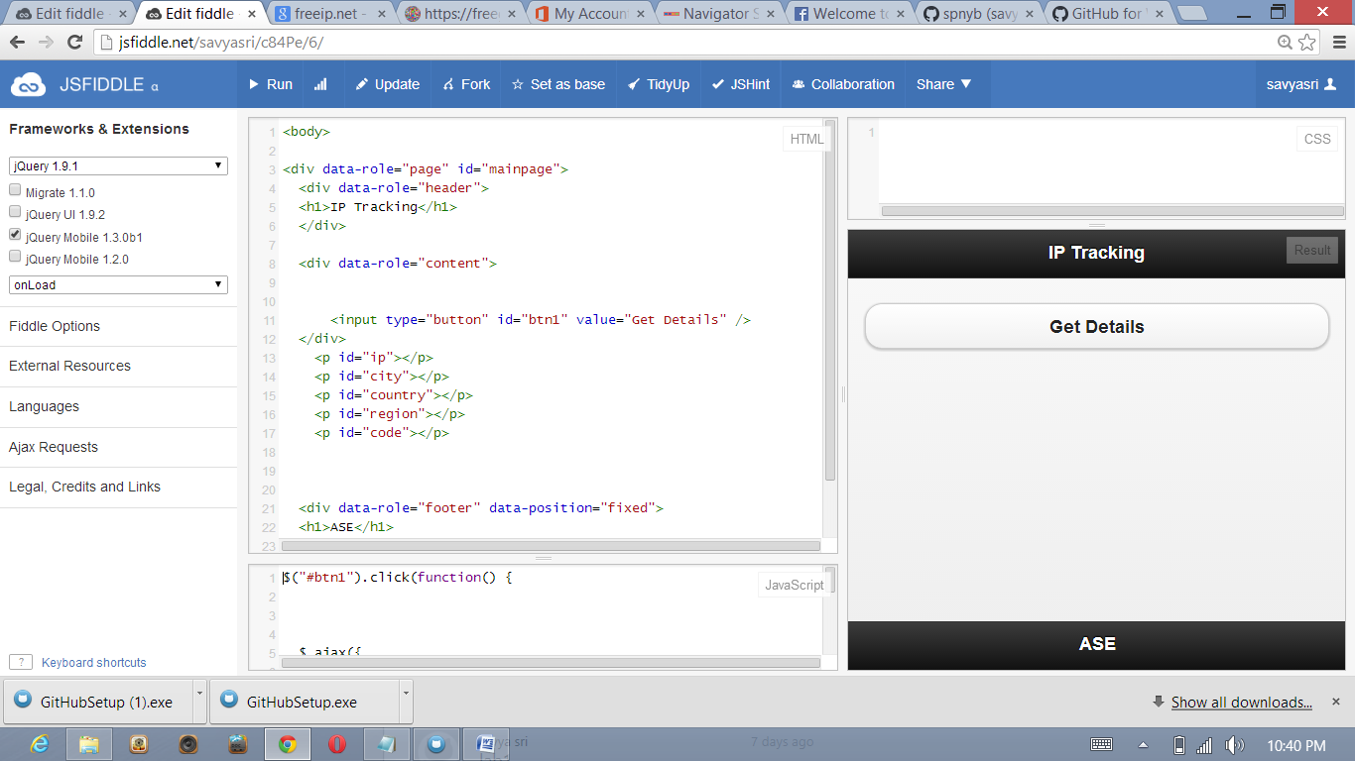

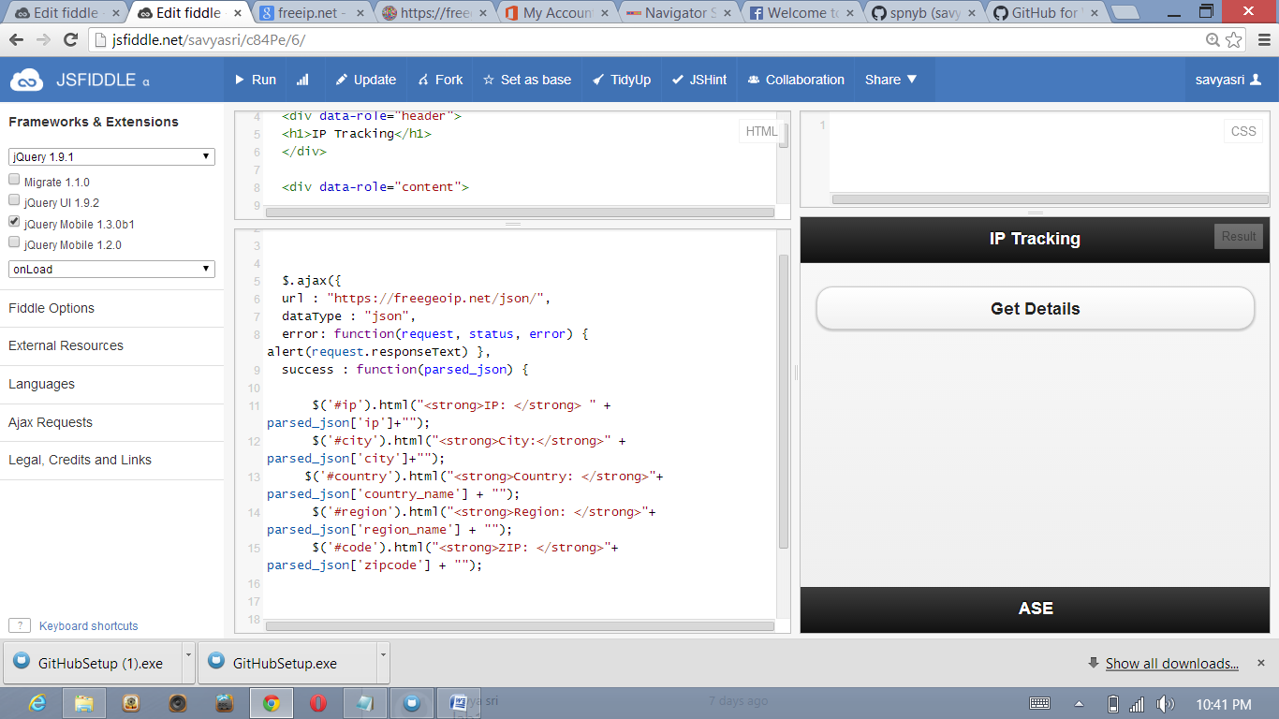

After clicking get details

we will get

IP,CITY,COUNTRY,REGION AND ZIPCODE

